Caitlan Nichols  
20 June 2024

Module 4.2 - MySQL Install

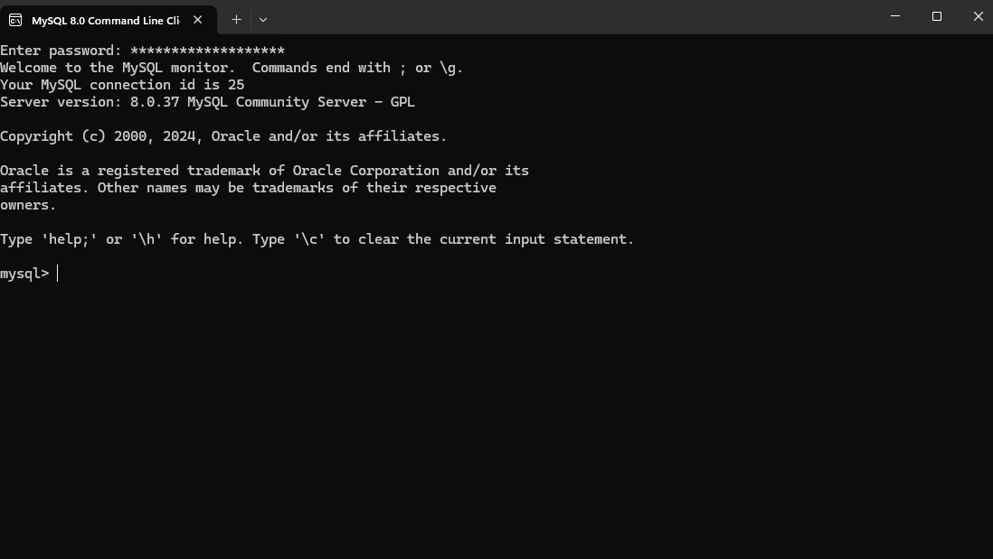

Databases

